Question: Color Palette Selector
You are provided with an incomplete HTML, CSS, and JavaScript file that represents a simple Color Palette Selector.
Currently, the page contains two color boxes and one “Selected Color” box.
Your task is to complete the code so that when a user clicks on any color box, the selected color is displayed in the “Selected Color” area.

Objectives
- Add two more color boxes with their names and HEX codes. #rrggbb 00-ff
- Change the height of all color boxes to 200px.
- When a user clicks on a color box, it should update the background color of the “Selected Color” box.

Constraints
- Do not change the order of the existing color boxes.
- Do not change the id or class attributes of any elements — they are used by the JavaScript code.
- Ensure that the styling is applied correctly according to the provided CSS.

Code:
<!DOCTYPE html>
<html lang="en">
<head>
<meta charset="UTF-8">
<meta name="viewport" content="width=device-width, initial-scale=1.0">
<title>Color Palette</title>
<style>
body {
font-family: Arial, sans-serif;
text-align: center;
margin: 20px;
}

.palette {
display: flex;
justify-content: center;
gap: 20px;
margin-top: 30px;
}

.color-box {
width: 150px;
height: 180px; /* TODO: ensure height is set correctly */
border: 2px solid #333;
cursor: pointer;
border-radius: 10px;
transition: transform 0.3s;
}

.color-box:hover {
transform: scale(1.05);
}

.color-name {
margin-top: 10px;
font-weight: bold;
}

#selected-color {
width: 200px;
height: 200px;
border: 3px solid #000;
margin: 30px auto;
border-radius: 10px;
}
</style>
</head>
<body>

<h1>Color Palette</h1>

<div class="palette">
<div class="color-item">
<div class="color-box" style="background-color: #FF5733;" data-color="#FF5733"></div>
<div class="color-name">Orange Red<br>#FF5733</div>
</div>

<div class="color-item">
<div class="color-box" style="background-color: #33C1FF;" data-color="#33C1FF"></div>
<div class="color-name">Sky Blue<br>#33C1FF</div>
</div>

<!-- TODO: Add two more color boxes here with their names and HEX codes -->
</div>

<h2>Selected Color</h2>
<div id="selected-color"></div>

<script>
const colorBoxes = document.querySelectorAll('.color-box');
const selectedBox = document.getElementById('selected-color');

colorBoxes.forEach(box => {
box.addEventListener('click', () => {
// TODO: Change the color of selected-color div when a color is clicked
});
});
</script>

</body>
</html>

Existing Output
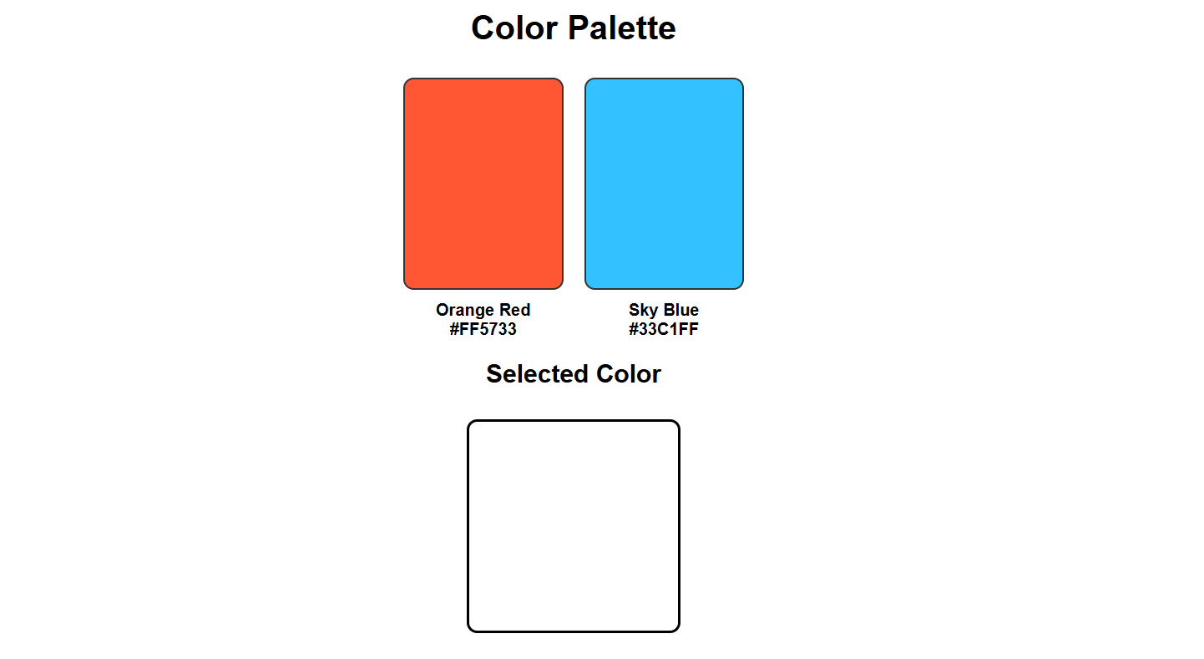
Excepted Output
